Project Design Phase-II
Data Flow Diagram & User Stories

Date | 04 October 2026
Team ID | SWTID-2026-2511
Project Name | Implement Client Script & UI Policy (Incident)
Team Leader | Ritika L
Team Members | Monisha A, Saranya G, Roshini A V, Yashika K
Maximum Marks | 4 Marks

Data Flow Diagrams:
A Data Flow Diagram (DFD) is a traditional visual representation of the information flows within a system. A neat and clear DFD can depict the right amount of the system requirement graphically. It shows how data enters and leaves the system, what changes the information, and where data is stored.

Example: (Simplified)


Our Data Flow Diagram: Incident Form with UI Policies & Client Scripts
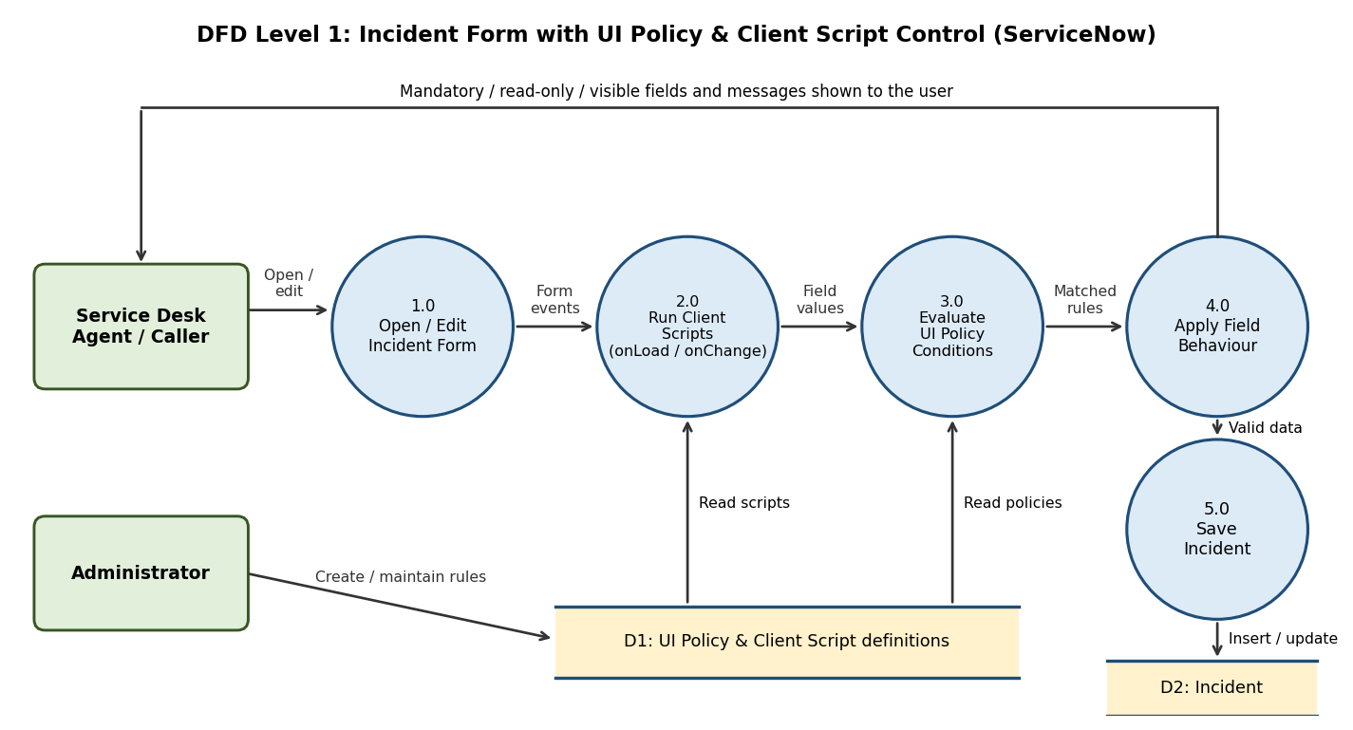

User Stories
Use the below template to list all the user stories for the product.
User Type | Functional Requirement (Epic) | User Story Number | User Story / Task | Acceptance criteria | Priority | Release
Service Desk Agent | Mandatory Fields (UI Policy) | USN-1 | As a service desk agent, I must enter Close code and Close notes when I set State to Resolved or Closed, so every resolved Incident has resolution details. | Both fields show as mandatory and the form cannot be saved until they are filled | High | Sprint-1
 |  | USN-2 | As a service desk agent, I must enter an On hold reason when I set State to On Hold, so the reason for the delay is recorded. | On hold reason shows as mandatory and the form cannot be saved without it | High | Sprint-1
 |  | USN-3 | As a service desk agent, I must select an Assignment group when Priority is 1 - Critical, so urgent Incidents are never left unassigned. | Assignment group becomes mandatory as soon as Priority is set to 1 | Medium | Sprint-1
 | Read-only Fields (UI Policy) | USN-4 | As a service desk agent, I cannot change Caller and Number after an Incident is saved, so key data stays correct. | Caller and Number are read-only on saved Incidents | Medium | Sprint-1
 |  | USN-5 | As a service desk agent, I cannot edit key fields on a Closed Incident, so closed records are protected. | Key fields are read-only when State = Closed | Medium | Sprint-2
 | Field Visibility (UI Policy) | USN-6 | As a service desk agent, I see On hold reason and resolution fields only when they apply, so the form stays clean and easy to use. | Fields appear or hide immediately when State changes, without saving | Medium | Sprint-2
 | Client Scripts | USN-7 | As a service desk agent, I want Subcategory to clear when I change Category, so I do not save a mismatched pair. | Subcategory resets when Category changes (onChange script) | Medium | Sprint-2
 |  | USN-8 | As a service desk agent, I am warned if Short description is empty or too short when I save, so Incidents have a clear title. | A message is shown and the save is stopped (onSubmit script) | Medium | Sprint-2
 |  | USN-9 | As a service desk agent, I see an alert when I set Priority to 1 - Critical, so I follow the critical Incident process. | An alert / field message appears when Priority = 1 (onChange script) | Low | Sprint-3
Caller / End User | Incident Quality | USN-10 | As a caller, I want my Incident to be logged with complete and correct details, so it is resolved faster. | Incidents are saved with all required fields completed | Medium | Sprint-2
Administrator | Configuration | USN-11 | As an administrator, I can create, activate or deactivate UI Policies on the Incident table without writing code, so rules can change quickly. | UI Policy applies to the Incident form with the chosen condition and actions | High | Sprint-1
 |  | USN-12 | As an administrator, I can move UI Policies and Client Scripts to another instance using an Update Set, so changes are controlled. | Update Set contains the configuration and loads without errors | Low | Sprint-3

